Paul-Robert Hipkiss
1002-340 Gloucester Street, Ottawa, ON K1R 1A8 (hipkiss@live.ca)

June 23rd, 2021

The Royal Canadian Mounted Police National Headquarters (Ottawa Detachment)
Headquarters Building, 73 Leikin Drive, Ottawa ON K1A 0R2

To Whom It May Concern,

I need your help.

Joseph Griffiths of McCague Borlack, 130 King Street West, Toronto, Ontario, Canada misled justice to judicator Giovanna Toscano−Roccamo who was present. He had argued that it was dark and that's why the driver, Gaetan Comeau, couldn't see me crossing the crosswalk when in fact it was daylight. Google it, Joseph Griffiths. It was daylight. It is a criminal offense to Mislead Justice according to Section 137 of the Criminal Code of Canada. According to notes taken by police, I was struck from behind while walking in a westerly direction. The crash was "life threatening." Paramedics Masse, Arcand, & Lefebvre arrived with ambulance and noted that I had been traumatised, and that I had symptoms of Acute Confusion, Head/Brain Injury, and back pain. Blood was also noticed on the ground. Their reports were written at approximately 18:37. I suspect that I was rushed thereafter to the Ottawa Hospital, Civic Campus, 1053 Carling Avenue, Ottawa, Ontario, Canada.

March 20th, 2019: Pre-Trial Conference Brief of the Defendants was submitted by lawyer Joseph W. L. Griffiths to the Superior Court of Justice of Ontario under Court File Number: 16-69137. On March 20th, 2019, Joseph Griffiths signed his brief. He wrote, "Trial is scheduled for 5 weeks starting March 1, 2021." The Pre-Trial with Giovanna Toscano-Roccamo (judge) was to take place at the court house on March 29th, 2019. To have preplanned a judicial procedure by scheduling a trial date nine days prior to the appearance of an impartial judge to weigh the debate for setting the actual date for trial in the first place let alone the date itself, is a crime of judicial influence, in other words, not allowing impartiality through judicial procedure. Was anyone else involved, Joseph Griffiths? Was lawyer Mikolaj Grodzki involved, too? I do not know. No wonder Honourable Justice Madame Giovanna Toscano-Roccamo wished not to make an order. She had to be presented as impartial to all the preplanned folly. She had to protect herself. That's why there was no seal, no order that day, nor a transcript that I had asked for or received to this date.

March 29th, 2019: I had a Pre-Trial Conference with Giovanna Toscano-Roccamo, civil judicator, at the Superior Court of Justice, Ottawa, Ontario, Canada. Joseph Griffiths, Michael Thiele, Mikolaj Grodzki, Syrmo Yerou, my three boys, and I were present. It appeared that there was a three-way teleconference device that was powered and another person on the other end listening. I was not privy to who may had been on the other line. A Crown Clerk was also present, but I did not see her record the Pre-Trial Conference. For the first time, I learnt that the man who hit me had died. I could not stop crying. Now, I shall never, ever know what happened that nanosecond in time. He was the only other true witness. Why did I not get to see him before he died? If I had only been able to see him at the Discovery. I did not care if he screamed at me or cried with me. I just demanded to hear him tell me his side of the story. The judicator told everyone, my family and I, that there would be a Pre-Trial 2 on October 31st, 2019. No Court Order, however. That's why I could never get an order when I always went to the Court House. Am I supposed to say thank you, Giovanna?

January 7th, 2020: Discovery 2 - Joseph Griffiths, Mikolaj Grodzki, a Crown Clerk, and I were present. I tried to ask some questions about what happened that day of the Car Crash. No-one wanted me to ask questions. So, I had a bipolar attack. I was going to put my first into Joseph Griffiths' skull via across the table. Imagine the force of such a leap. Mikolaj Grodzki grabbed my arm. (I became bruised days later.) I was about to kill Joseph Griffiths for triggering my acquired brain into much confusion concerning dates that were not even relevant to the case. Like, how was whatever I did in 1982 relevant to 2014? Thus, as in the case with Patricia Lawson of McCague Borlack during Discovery 1, Joseph Griffiths did the same - trigger a victim. But, what he as she did is place many other people in harms way, never mind me. You are a criminal, Joseph Griffiths.

December 12th, 2020: Apparently there was an Ontario Superior Court of Justice "Decision" being made without my presence or my consent to my privacy. Adriana Doyle, judicator, made an order for me to be assessed once more. Was this motion practised on Zoom? Why was I not privy to it? To force a person into an association without he or she present. That is like being forced to walk the plank and not been given a chance to rebut. That's criminal. You mean that I was not able to stand up against Joseph Griffiths and insist that he not force me to relinquish my fundamental human right. Was the jib up again? Besides, La Prima Facie e Hopital, not 7 years later. And to top things off, I went to be assessed again, but TD couldn't even arrange transportation for me to go all the way up Carling Street Hill, Ottawa, Ontario, Canada to a place near the Hospital called Pro Physio & Sport Medicine Centres, 1081 Carling Avenue, Ottawa, Ontario, Canada. In -18 Celsius. They sure did think of ways to criminally harass a victim.

January 18th, 2021: I went to have a Neuropsychological Assessment with Paul Duhamel. He did not wish to assess me. I went all the way up Carling Avenue Hill in -18 Celsius because McCague-Borlack did not secure transportation for me, the victim. It was there, half way up the hill, that I saw Joseph Griffiths in a black sedan with a zoom-camera taking pictures of me as I had stopped casually to readjust my spine to get up the hill some more - privately investigating a plaintiff. "That's highly criminal." You need a judicator's order for that. Next, I reached the Pro Physio place at Parkdale Avenue and went to readjust at the doctor's table. He didn't like that. I had no choice. My spine had become all messed up. Besides, I thought he was a neurologist plus a psychologist. I thought he'd be trained to help me. My readjustments must have told him something, that I was disabled? Then, after feeling a little better, I began to talk about what I wished to discuss. He frantically went in and out of the assessment's glass-room to confirm with Joseph Griffiths, who wasn't supposed to be there anyhow, and told me that he could not proceed. He did not wish to discuss documents that I had brought with me. Thus, I went through all that pain for nothing. Not even, "Mr Hipkiss, sit up straight. It will be better for your back." He saw my back readjust, yet no advice. Unprofessional conduct all around. That was criminal harassment what I went through from start to finish all because no-one read the hospital file.

March 1st, 2021: Supposedly, there was a Pre-Trial with judicator Robert Beaudoin. It was held at lawyer Mikolaj Grodzki's office over Zoom's Internet Video-Conferencing Services, which was not decoded either, thus available for anyone to download. It was not being recorded by a stenographer or Crown Clerk for transcript purposes, so I told Robert Beaudoin. (It may had been recorded like a YouTube video but not for transcript.) He asked me why I wanted it to be recorded. I demanded it to be recorded in case I needed a copy in writ. This was the same discrimination that medical doctors embraced when I demanded my medical files. What is wrong with this country? Secrecy! That's what. And I knew it long ago. So, thank goodness that I did record everything myself. I walked out. That was not a "Pre-Trial." It was a make-shift mediation. Transparency is austere, Robert Beaudoin. There was never an order for a Pre-Trial for March 1st, 2021 in the first place by Giovanna Toscano-Roccamo on March 29th, 2019. I'm slow but not stupid. Another crime. Others that were present were Wayne Nunes of TD Insurance, Insurer Kevin Temple, Alice as Clerk, Mikolaj Grodzki, Joseph Griffiths, and Todd McCarthy - of course, I.

March 5th, 2021: Mikolaj Grodzki gave me a photocopy of a letter lawyer Alison Campbell sent to him on February 25th, 2021 - almost 2 weeks before. The letter was an authorisation on behalf of my wife for Alison Campbell to seek a Change of Motion in Family Court for child support of $3.00 per month that was owed for 7 years plus her court cost that she scammed sexist judicator Stanley Kershman into abusing the Family Responsibility Office (Child Support Office) as her own collection agency. Why so late, Alison Campbell? The best interest of my boys according to the Act would have been for you and Mikolaj Grodzki to be in Family Court fighting against TD Insurance et al. years and years ago, especially for better financial support for food and an appropriate dwelling like a two-bedroom apartment at least, so that I could go and nap if need be with my new brain while the boys were visiting and being boys, and instead of the boys sleeping on the floor in sleeping bags. Victim & Child Shame Where was everyone 5 years ago?

March 7th, 2021: I went to see Mikolaj Grodzki. I had previously gave him medical documents, contracts, and my portfolio. They were in bags. Syrmo Yerou had helped me deliver them. But, he had not touched them. I trusted this man. He wasn't preparing for trial. And here I thought we were going to make case law as he had promised me. This was a scam all along. Criminal!

March 14th, 2021: I texted Mikolaj Grodzki asking him "What time do I have to be at your office tomorrow to speak to a judge on zoom?" I advised him "The police will be involved with you personally. I told you 'Bow Out' gracefully. Tell me what time!?!" No response. Criminal!

March 15th, 2021: I got up in the morning at 05:55 hundred hours. Got ready. I went for a walk and waited for a text or a phone call from Mikolaj Grodzki as to where and when the Trial would be located like perhaps at his office yet I did not know. I thought that something like Zoom Video-Conferencing would be involved. But where? I got actious. So, I walked. I walked. I walked. No response. I had texted him "What time?" I wanted to know when and where I had to go. Nothing. I went to the apartment and cried. Everything behind my back. That's a crime.

March 15th, 2021: It became crystal clear. Mikolaj Grodzki never wanted a trial. What lawyer never calls witnesses? It dawned on me. He was supposed to request in writ My Witnesses to Appear for Trial: Anne, Christine, Christopher, Elleni, Eva, George, Joanne, Jonathan, Kiti, Lula, Syrmo, Timothy, and Wally. He did nothing! Me as witness?

March 15th, 2021: Denise Hughes of Security National Insurance Company with police number 73825156 and claim number 018133598-03 certified a Settlement Disclosure Notice on March 15th, 2021 for $1,000,000.00. Denise Hughes digitally signed the settlement at 10:54 on March 16th, 2021. So, this person certifies a settlement the day before this same person signs same settlement. Conspiracy? The jib went way up. Offer included $0.00 for income replacement. I guess Iraq was in vain. $0.00 for rehabilitation. These people do not wish to fulfil their legal duty to bring me back to whence I was. $0.00 for a caregiver. No-one really wanted me to have a working stove let alone other things, so this did not surprise me that an insurer would not want to take care of me. Welcome to Canada. Criminals, really. I never asked for this money. I demanded health, rehabilitation, and a trial. I warned everyone about trying to force me to relinquish my Freedom of Speech. Why would I in the face of so many crimes? Yet, even more criminal: $0.00 for death and funeral expenses. Are you kidding me? Health practitioners clearly have agreed that life expectancy is likely to diminish due to brain injury or brain trauma. So, if I die due to an aneurism or stroke due to my injury, my boys will not be able to sue Security National Insurance et al. or TD Insurance Meloche Monnex et el.? To sue is to practise speech. Just because I need help and it is the law for me to demand help, I must muzzle my vocal chords? Never! I warned everyone about this fact on December 10th, 2019 within the first page of my Victim Statement. No-one listens to a victim in Canada? Not, I guess. I must get my hands on that stupid settlement to prove I'm right. I'll throw out numbers. They'll give it to me sooner or later. Then, I'll have proof. Then, I can go to the police.

Why do I have to defend my own Freedom of Speech in my own birth place, Canada? Why will no-one stand up with me, and more importantly, for me? I am disabled. I am slow. I am not stupid. It's called EXTORTION, my kind people. Yes, I need help, but not at the hand of a gun - sign here and shut up! Never! I taught many people how to speak. I shall never relinquish my own. Yet, I need help. To deny me health care, help, and rehabilitation is a crime of malfeasance as well as the failure to provide the necessities of life. Why? Because of my Freedom of Speech? And now, I cannot sue for more help? It was my entire right side that was damaged as a result of the Crash, yet now my left knee cap is seriously failing. What do you do in a court room, roll burgers? No! You exercise your Freedom of Speech in order to articulate and argue the practice of law. The RCMP has the duty to protect my Constitutional Rights.
I demand that you order these lawyers Joseph Griffiths (613) 751-3430 and Mikolaj Grodzki (613) 563-1131 to protect my speech and provide me with health care support with Dr Andréanne Côté (613) 233-8700, and for everyone to fix my mouth please.

Thank you in advance,

Paul-Robert Hipkiss
(https://photos.app.goo.gl/fGCDQDuaoq3dqCYX7)
I was...
I am not...
I promoted your freedom and your way of life in my classrooms to people that wished you dead.
And now, you try to take my own freedom away from me? My regret is that I believe in Justice.

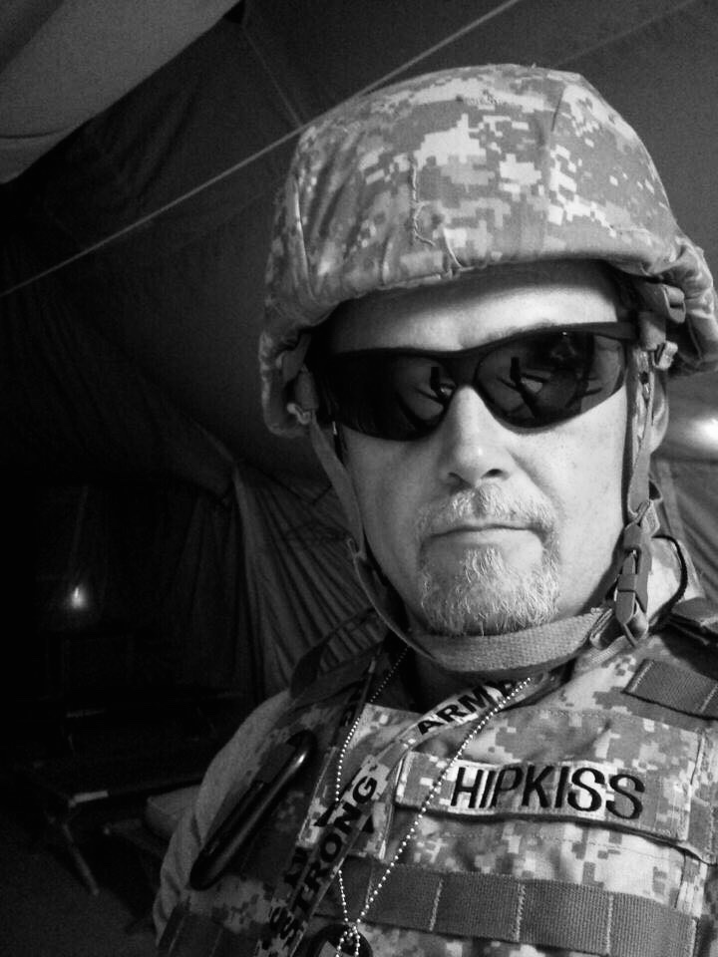

Paul-Robert Hipkiss
Camp Liberty, Baghdad, Iraq
2011

